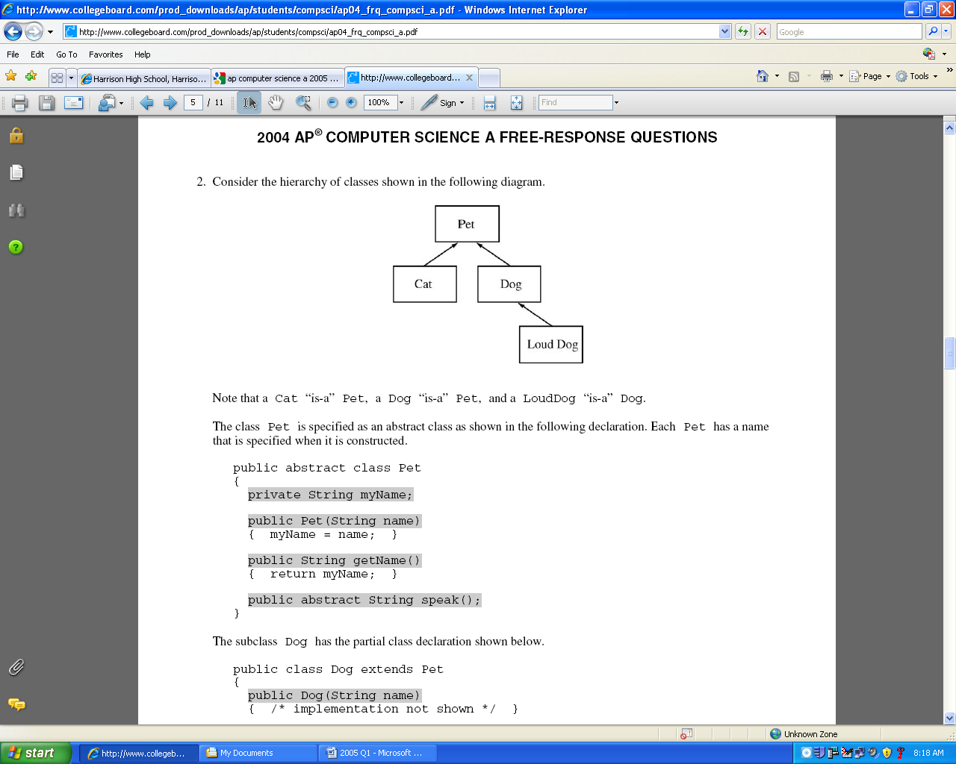

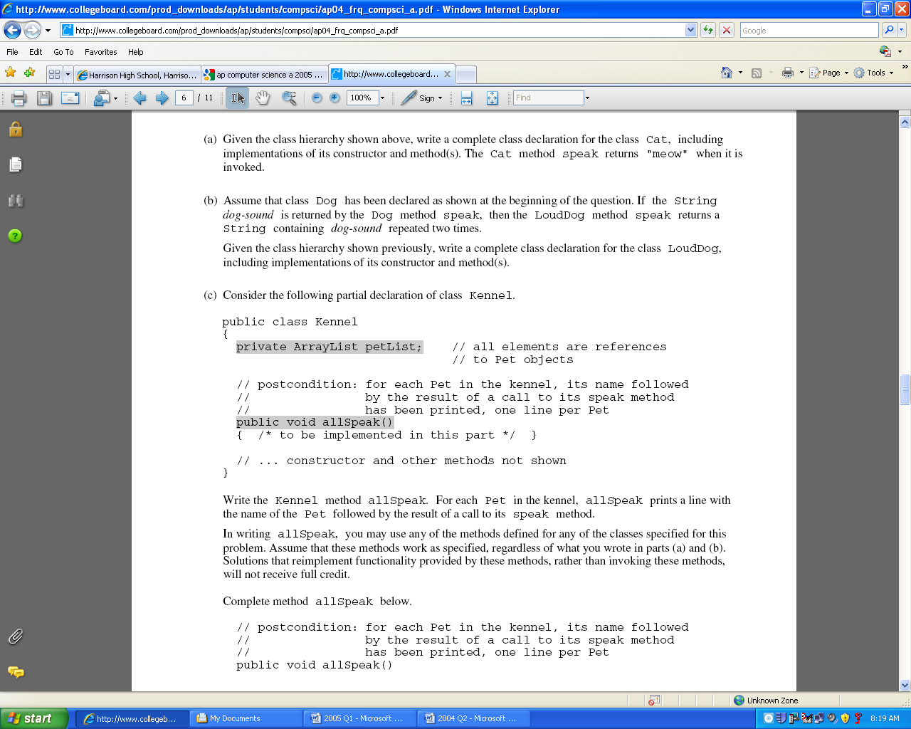

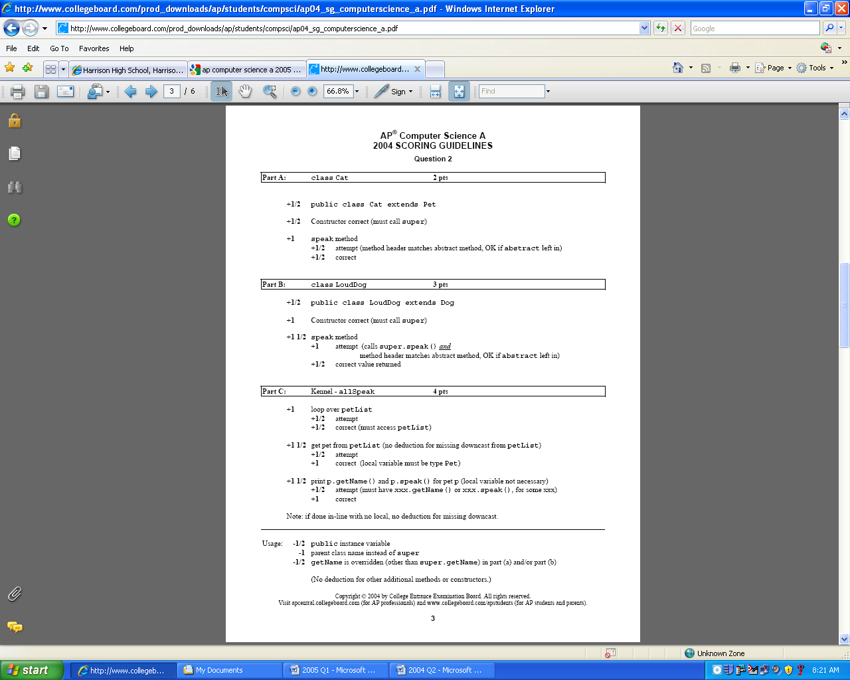

Code that Answers Question

**public class Dog extends Pet**

{

public Dog(String name){

super(name);

}

public String speak(){

return "woof";

}

}

**public class Cat extends Pet**

{

public Cat(String name){

super(name);

}

public String speak(){

return "meow";

}

}

**public class Kennel**

{

private ArrayList petList;

public void allSpeak(){

for(int k=0; k < petList.size(); k++){

Pet p = (Pet) petList.get(k);

System.out.println(p.getName() + " " + p.speak());

}

}

}

// ARRAY VERSIOM

public void allSpeak(){

for(int k=0; k < petListlength; k++){

Pet p = petList[k];

System.out.println(p.getName() + " " + p.speak());

}

}

**public class LoudDog extends Dog**

{

public LoudDog(String name){

super(name);

}

public String speak(){

return super.speak()+super.speak();

}

}

**public abstract class Pet**

{

private String myName;

public Pet(String name){

myName = name;

}

public String getName(){

return myName;

}

public abstract String speak();

}